Task 1

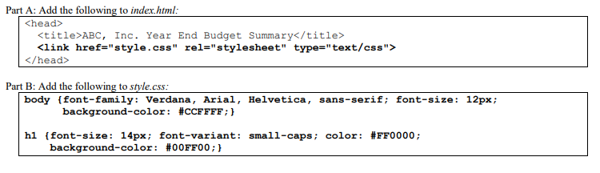

Task 2

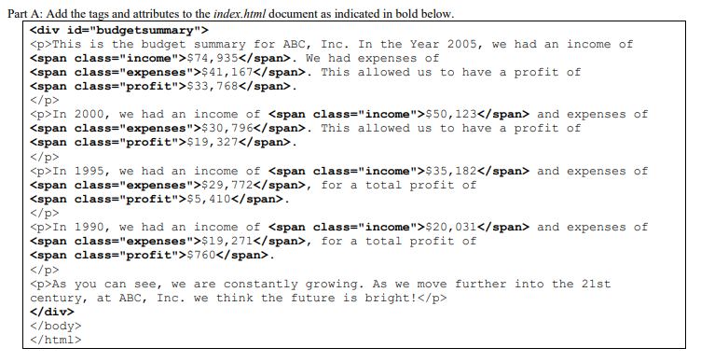

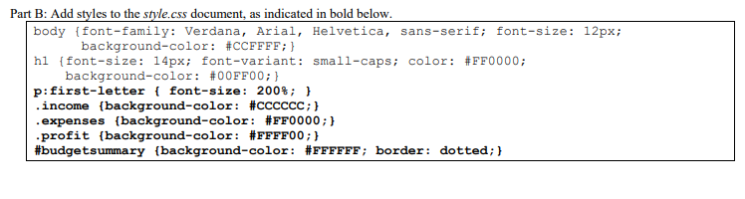

Task 3

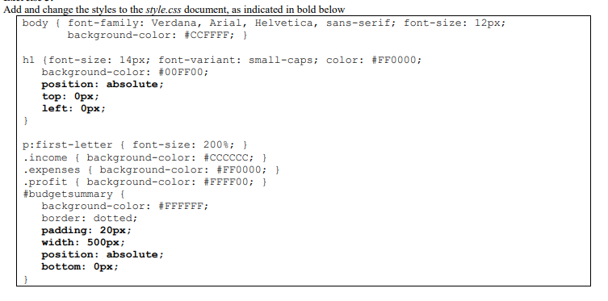

Task 4

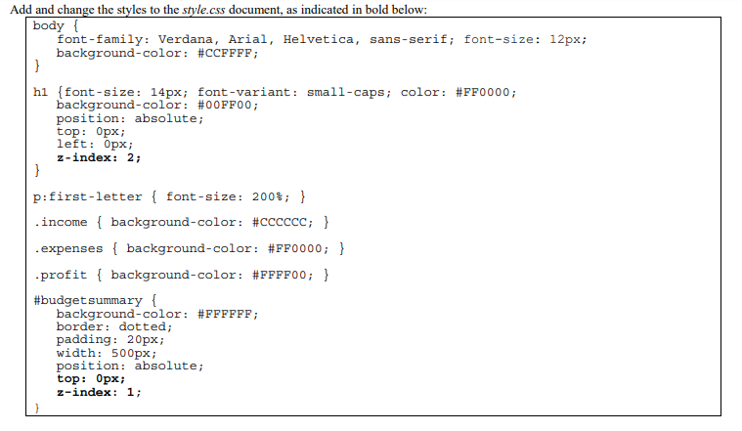

Code html file:

<!DOCTYPE html>

<html>

<head>

<meta charset="utf-8">

<title>ABC, Inc. Year End Budget Summary</title>

<link href="style.css" rel="stylesheet" type="text/css">

</head>

<body>

<div id="budgetsummary">

<p>This is the budget summary for ABC, Inc. In this year 2005 we had an income of <span class="income">$74, 935</span>. We had expenses of

<span class="expenses">$41, 167</span>. This allowed us to have profit of<span class="profit">$33, 768</span>.

</p>

<p>In 2000, we had an income of <span class="income">$50, 123</span> and expenses of <span class="expenses">$30, 796</span>. This allowed us to have profit of

<span class="profit">$19, 327</span>.

</p>

<p>In 1995, we had an income of <span class="income">$35, 182</span> and expenses of <span class="expenses">$29, 772</span>, for a total profit of

<span class="profit">$5, 410</span>.

</p>

<p>In 1990, we had an income of <span class="income">$20, 031</span> and expenses of <span class="expenses">$19, 271</span>, for a total profit of

<span class="profit">$760</span>.

</p>

<p>As you can see, we are constantly growing. As we move further into 21st century, at ABC, Inc. We think the future is bright!</p>

</div>

</body>

</html>

Code css file:

body{font-family: : verdana, arial, helvetica, sans-serif; font-size: 12px; background-color: #CCFFFF;}

h1{font-size: 14px; font-variant: small-caps; color: #FF0000; background-color: 00FF00;

position: absolute;

top: 0px

left: 0px

z-index: 2;

}

p:first-letter {font-size: 200%;}

.income {background-color: CCCCCC;}

.expenses {background-color: #FF0000;}

.profit {background-color: #FFFF00;}

#budgetsummary {background-color:#FFFFFF; border: dotted;

padding: 20px; width: 500px; position: absolute; bottom: 0px;

top: 0px; z-index: 1;

}

Output:

